How to amend a miscellaneous booking?

Once a Miscellaneous booking has been created and an amendment needs to be done, this can be also done via the Miscellaneous functionality in DOTWConnect. To do this, one must click on the MISC tab in the Operations Tab.

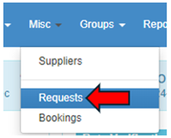

Once the drop-down list shows, the REQUESTS tab would need to be clicked.

The next page will load, bringing one to the Look Up Miscellaneous Details page which will allow one to filter for a Miscellaneous booking. The easiest way to pull up an existing Miscellaneous booking would be via searching via the DOTW MISC #. To do this, one would need to look for the DOTW MISC # row in the right part of the page and input the MISC # here.

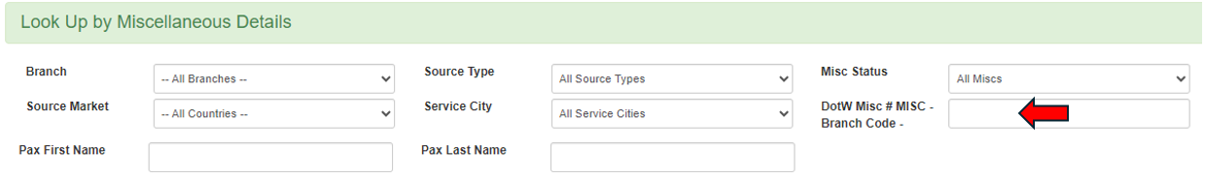

Once the DOTW MISC # has been input in the box, the APPLY FILTER button can now be clicked.

A short summary of the Miscellaneous booking will load in the page. One must click on the VIEW BUTTON to allow a user to load the full booking detail of the Miscellaneous.

DOTWConnect will proceed to load the full booking detail of the Miscellaneous. There are two buttons that one can click/access to amend a Miscellaneous booking:

- EDIT MISC button; and
- CHANGE PRICE button.

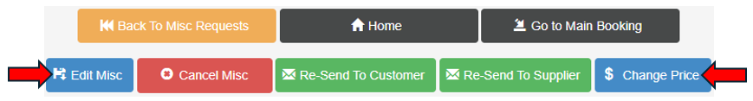

EDIT MISC button: will allow one to amend the booking details, dates and cancellation deadline/penalty % of the booking.

CHANGE PRICE button: will allow one to amend the supplier cost, markup % and the selling price individually and accordingly. Clicking on the Update button will save the new cost/markup % and price.

